Medical research: An accidental death
Friday, 07 March 2014 12:26 Gary Finnegan
Inspired by online privacy fears, new EU data protection rules could deal a major blow to medical research. How did science get caught in the cross-fire?
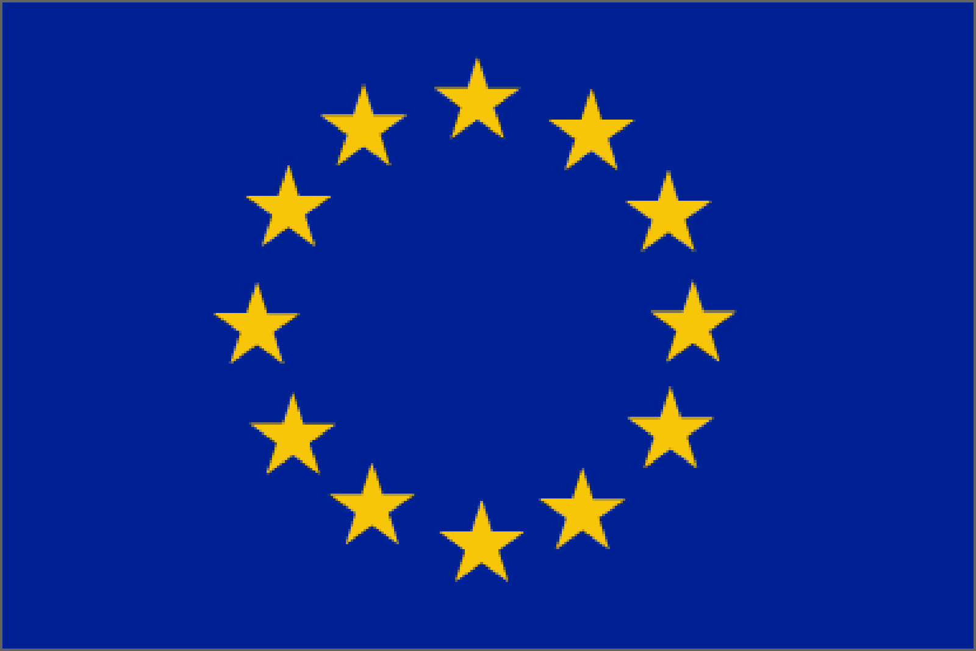
Blame Edward Snowden. Blame US intelligence services. Or even overzealous MEPs. But somehow, heightened fears over data protection could be about to tie the hands of medical researchers – with disastrous effects.
Proposed new rules, as currently drafted, would require researchers to get “specific consent” from patients when they use any of their personal data. That might not sound unreasonable but it represents a tectonic shift.
At the moment, when patients participate in a survey, share data with cancer patient registries, or donate blood and tissues samples to biobanks, they can give “general consent” for this material to be used for research purposes.
The data is carefully guarded; access to the database, registry or biobank is strictly controlled, and the material is used for the purpose intended – medical research. The participants understand this, the researchers understand this.
But some MEPs want researchers to get specific consent from each and every individual whose data they use, for each and every project they do. This chimes with our desire for transparency and individual rights. But it is a disaster.
It ain’t broke
Consider, for example, a large, longitudinal study where a university has surveyed tens of thousands of people every 20 years for several decades. They might have asked about income, family composition and educational status; maybe they inquired about diet, lifestyle, and smoking.
What if, in 20 years, the survey is repeated and a new team of researchers from the university wants to compare these results with the 2014 cohort – or with the 1994 cohort. They want to look at something that wasn’t thought of when the survey was originally done – let’s say, whether the relationship between occupation and diabetes has changed between 1994 and 2034. Are they to attempt to trace the tens of thousands of people who participated in that 1994 edition of the survey?
The same goes for biobanks and cancer registries. Over time, it stands to reason that many of the people whose information is contained in these databases have died. Sad though it is, this is partly what makes this data so valuable; it’s a chance to figure out what factors influence survival.
Maybe scientists will want to test a potential new treatment on tissues samples from a biobank. How could you or I give specific consent to research on therapies that do not yet exist?
Maybe they will use supercomputers to mine massive data sets to help divide patients into sub-categories – or even to redefine diseases – in ways we cannot imagine today.
The only way to achieve this is to ask patients at the outset if they are happy for their data to be used for all medical research, currently known and unknown.
This is pretty much how it is today. If you are content with that (as I would be) then you participate in the survey or the patient registry or whatever. If not, there is no obligation to opt in. The system ain’t broke.
Big data
The timing could hardly be worse. There is considerable excitement about the potential of “big data” to help accelerate the development of new therapies and usher in an era of personalised medicine. Far from causing ethical problems, there will be several benefits.
Take paediatric research. The aversion to including children in clinical trials means that most of the drugs currently used in minors have not specifically been trialled in people of their size and metabolism. Mostly, dosage is extrapolated from trials on adults. That is slowly changing as the European Medicines Agency is giving licenses to conduct paediatric investigation plans (PIPs), yet it is still a sensitive area.
But data is out there. Children have been treated for decades with medicines that were never trialled in kids. Some have fared well, some have not, and for some the drugs made no difference. Which kids did well? Which did not? Why?
The answers are out there in hospital files and GP surgeries. Pool even a fraction of this information (anonymised, of course) and you’d have some of the largest clinical datasets imaginable.
The same principle applies in other areas whether research is taboo (like pregnancy) or where consent poses ethical challenges (like dementia research).
Digital spies
So, back to the European Parliament: Where did it all go wrong?
It started out with a simple update of outdated laws. The European Commission proposed new rules to safeguard privacy because most of the legislation in this area was drafted before Google was a verb; before Facebook had more users than Europe has inhabitants.
The first draft was an effort to cater for a world where online shopping and social media are a fact of life, and websites collect mountains of personal data every time we click the mouse.
The proposed rules would, under normal circumstances, have been tweaked a bit as it passed through the European Parliament, defaced a little further by national governments, but then turned into law in 28 Member States.
But then something big happened. Edward Snowden, a former US intelligence officer, became the most famous whistle-blower of the Internet Age. He shone the spotlight on an American-led global surveillance operation in which some telecoms and tech companies were (perhaps reluctantly) complicit.
No longer could we be confident that our emails were secure or that our phone records were private. We were awakened to the fact that when we give over personal data to a company or an agency that it may not be stored safely away, used only for the purpose intended.
Intelligence agents were picking through our online identities, tapping search engine databases, and spying on charities like Medicins du Monde and UNICEF.
Even Angela Merkel was not immune. Her personal mobile phone was bugged. So were EU offices in Brussels and national governments in Spain, France, China and beyond.
Overreaction
EU lawmakers freaked out. And, with elections looming in May, they want to be seen to take a stand. So when the new data protection rules landed at the Parliament’s civil liberties committee, they made a series of amendments aimed at safeguarding our right to privacy and ownership of our personal data.
But their response has been a massive overreaction with major unintended consequences for health. This is the legislative equivalent of watching a car crash in slow-motion. You can see the driver over-correcting to avoid a pothole but steering the bus into the ditch.
Research agencies, patient groups, academics and companies are terrified and are pushing for medical research to be exempted. Professor Dermot Kelleher, President of the Federation of European Academies of Medicine, has written to MEPs urging a rethink.
The European Parliament is sleepwalking into catastrophe. We can only hope they see the light before it is too late. n
Gary Finnegan is a former Editor of IMN and the Irish winner of the EU Health Prize for Journalists in 2009, 2010, and 2011. He was the 2013 winner of the GSK Medical Media Award ‘Professional medical media – opinion’

